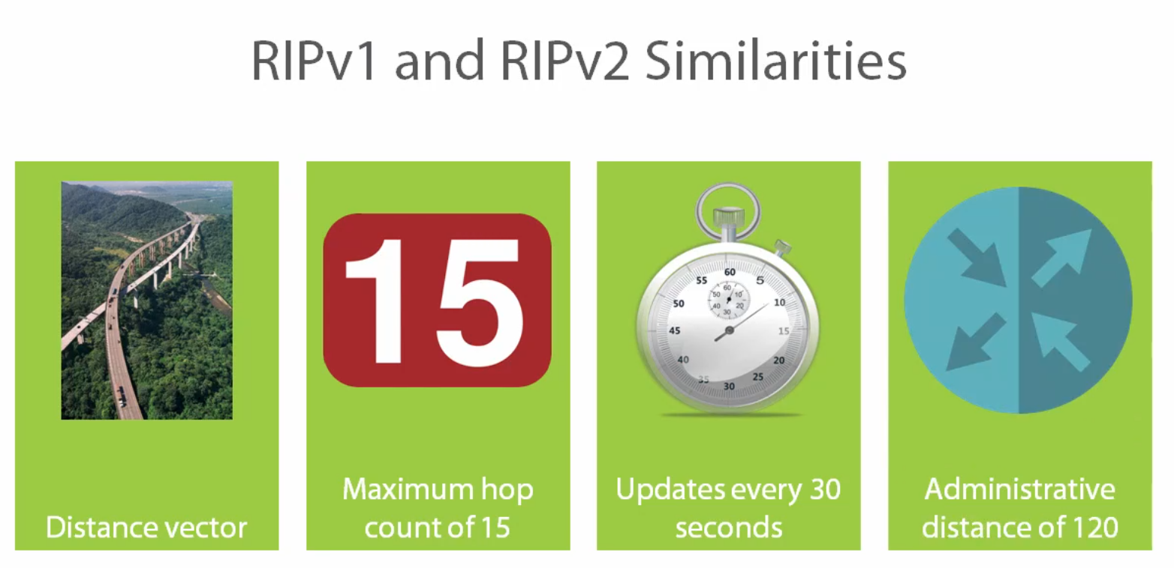

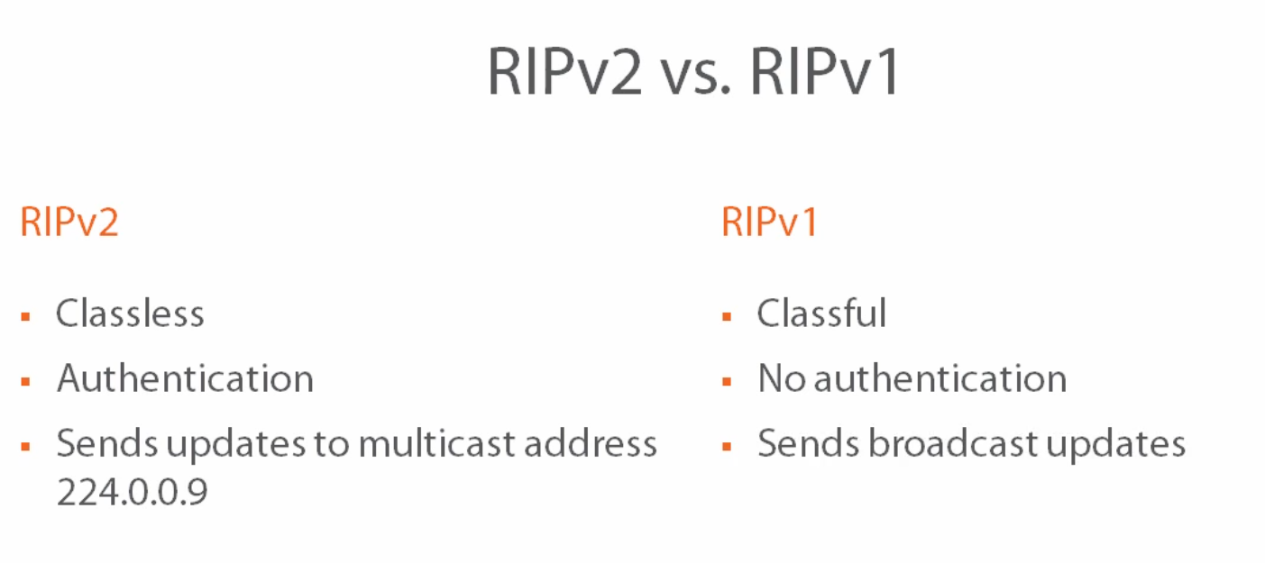

RIPv2 - classless - send the subnet mask along with the prefix

- allow authentication

- sends updates to multicast address 224.0.0.9

RIPv1 - classful - send only the classful network or the major network

- no authentication

- snes broadcast updates

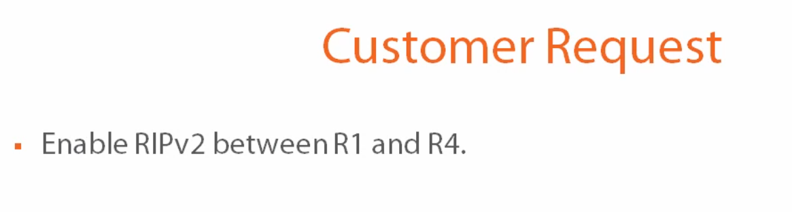

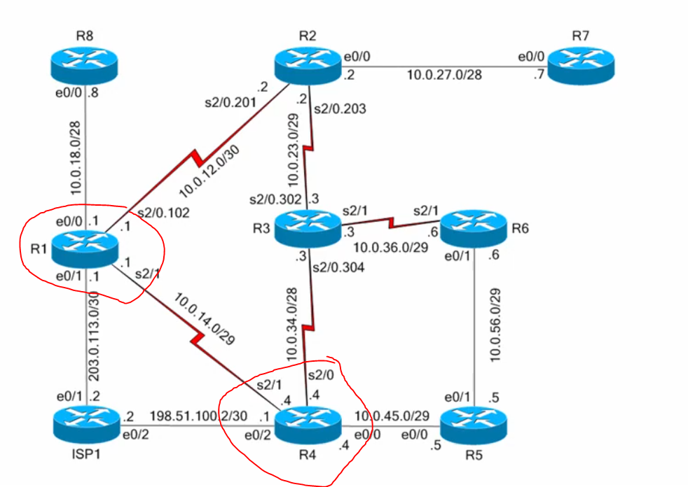

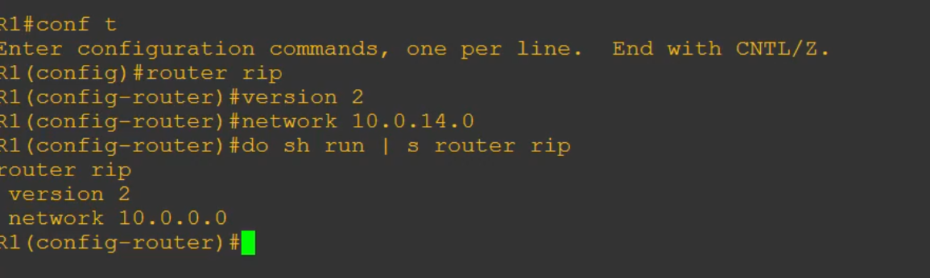

The reason you got 10.0.0.0 because rip changed to a classful network

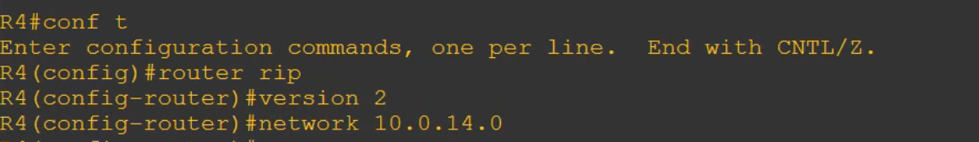

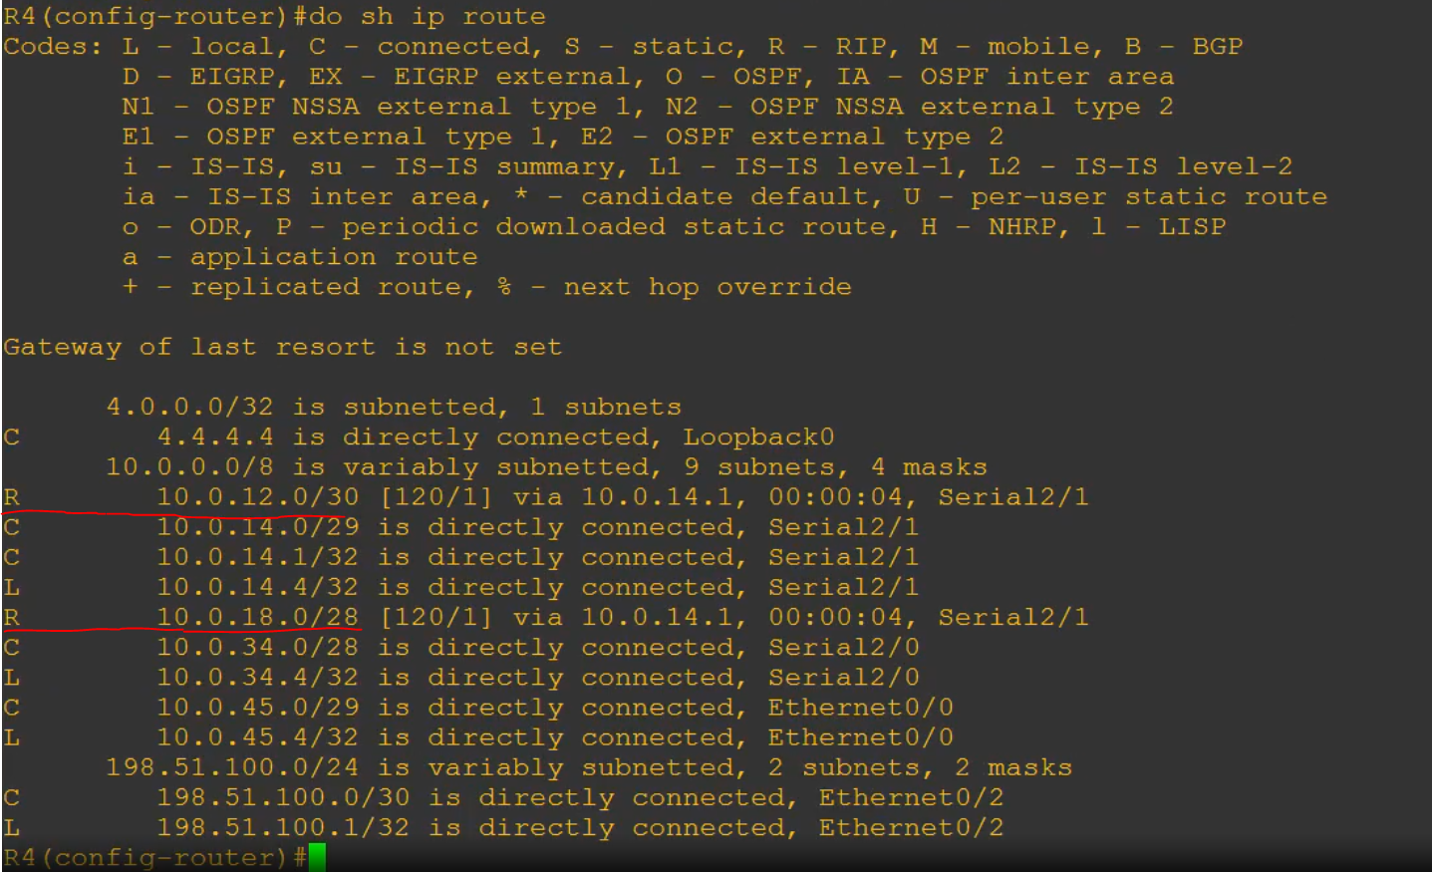

R = rip-learned routes

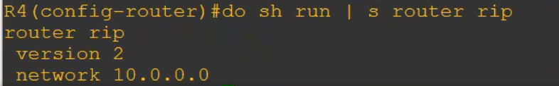

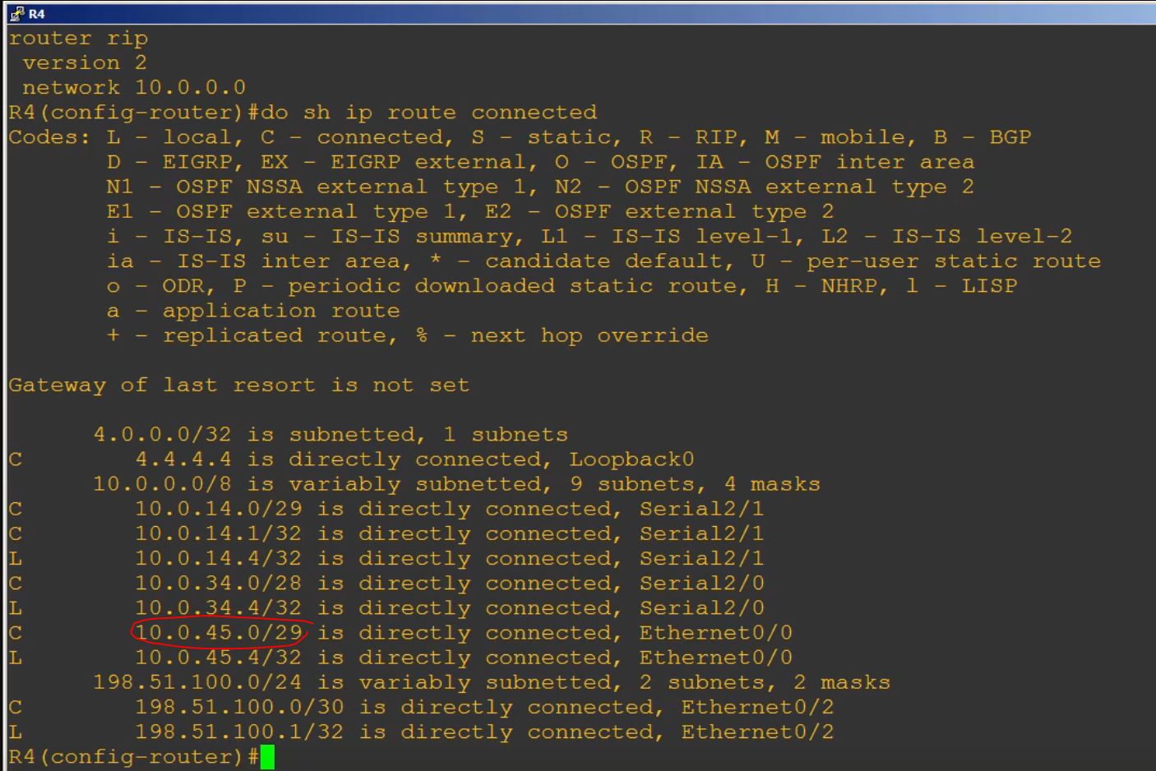

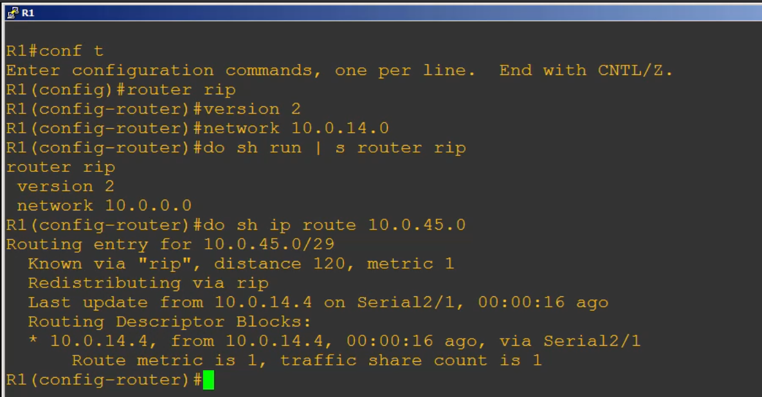

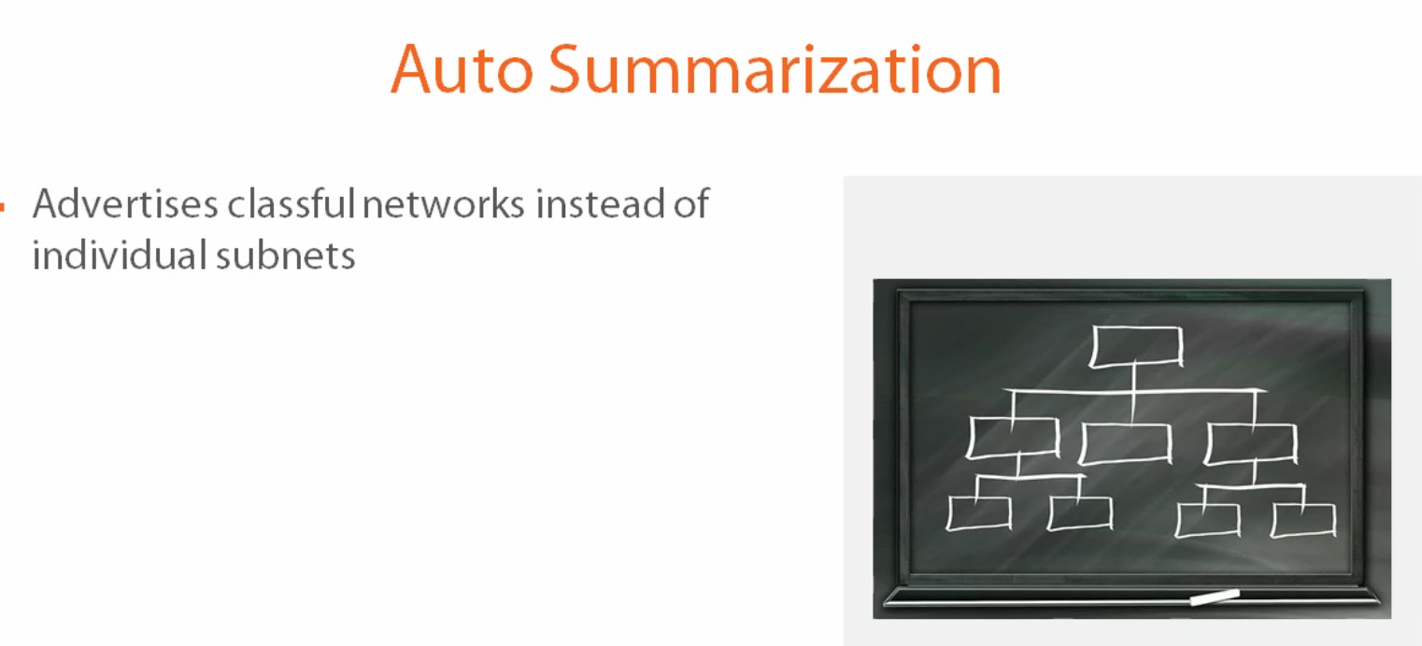

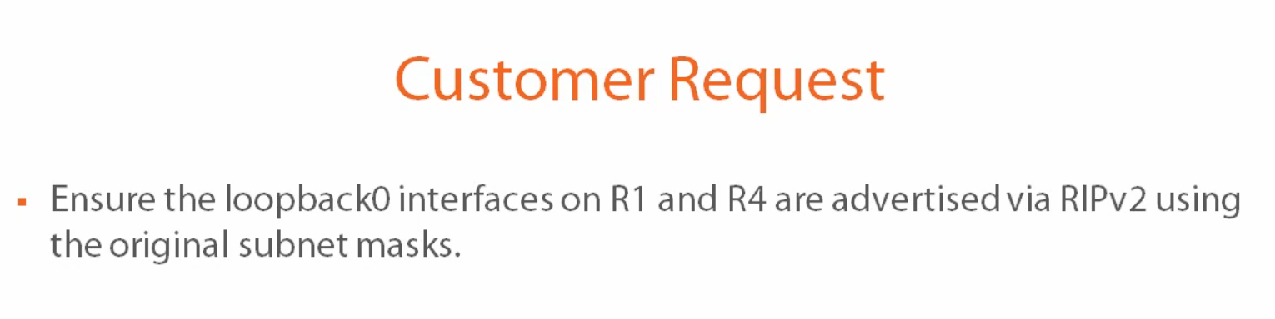

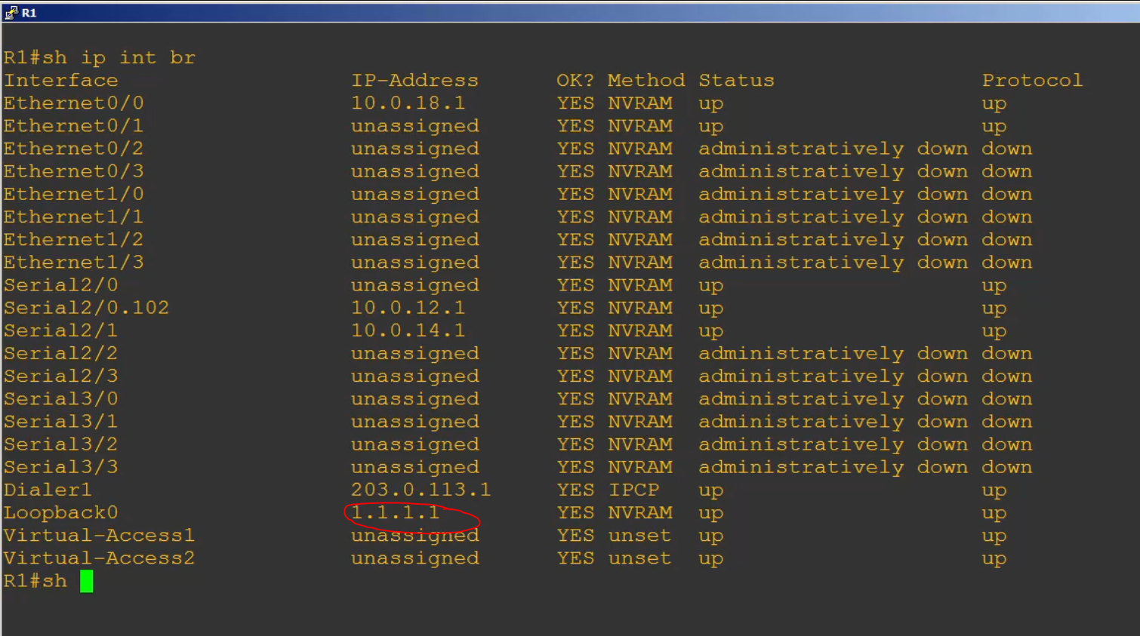

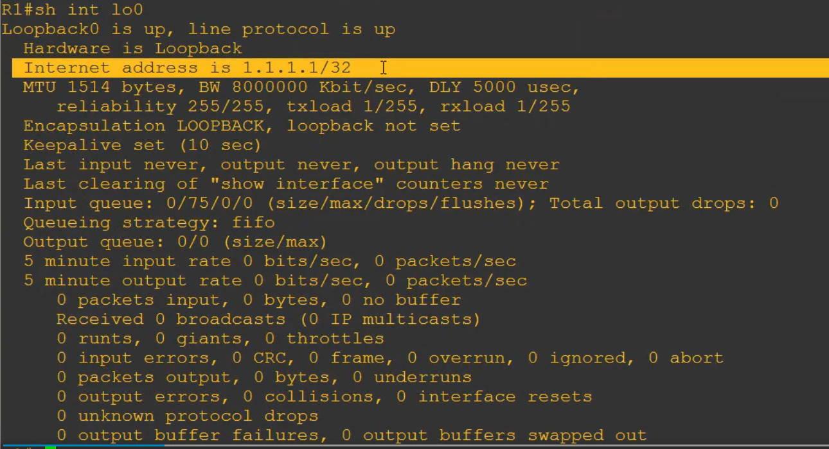

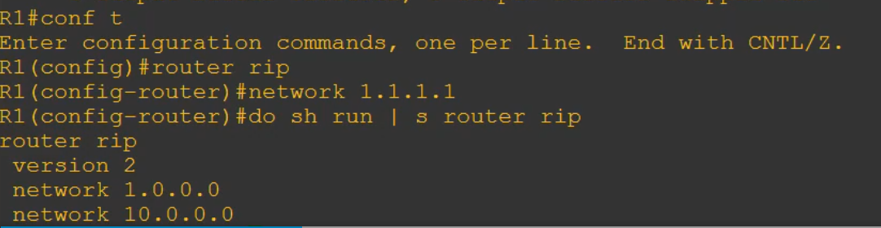

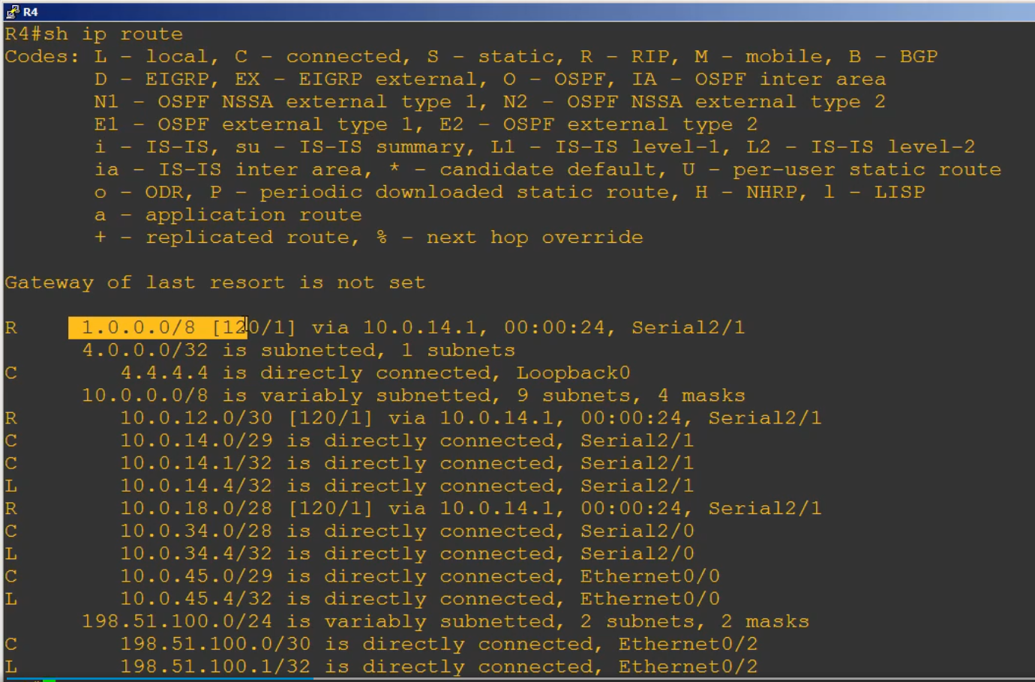

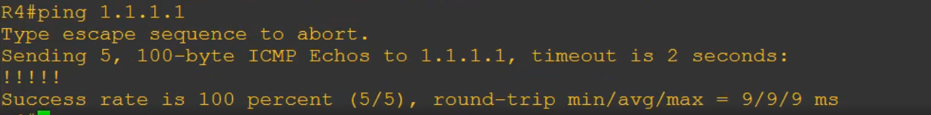

But why didn’t it show on the routing table as 1.1.1.1/32 instead of 1.0.0.0/8?

Doesn’t RIPv2 support variable length subnet mask? Well, yes it does. And in face we know it beause we see this 10.0.12.0/30, for example, prefix is showing up from R1, what’s going on, lets go back to switch 1

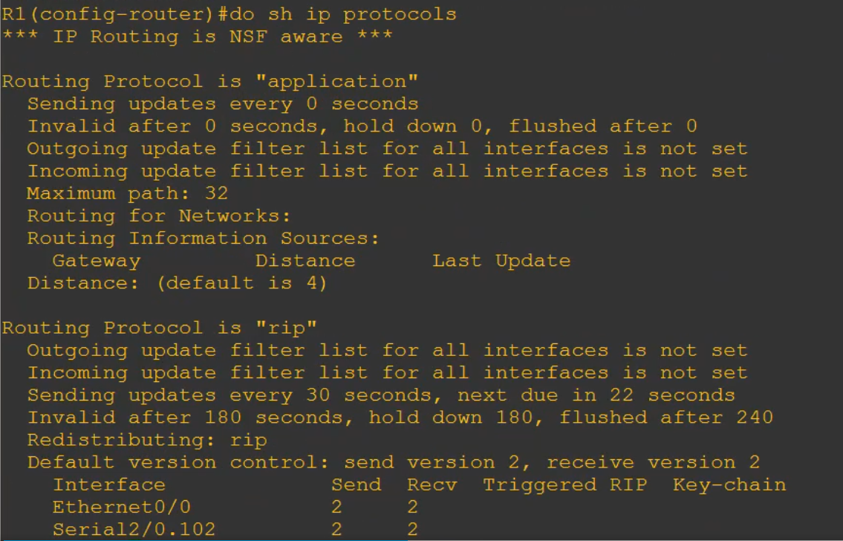

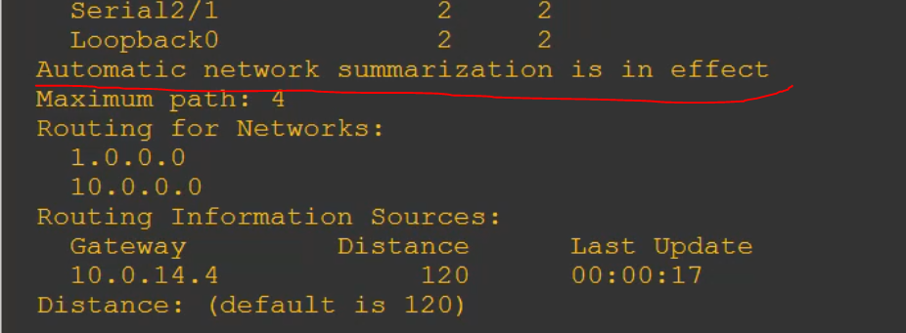

What is mean in red underline is that, r1 gonna take 1.1.1.1/32 network and summarise it as 1.0.0.0/8 and send it to R4

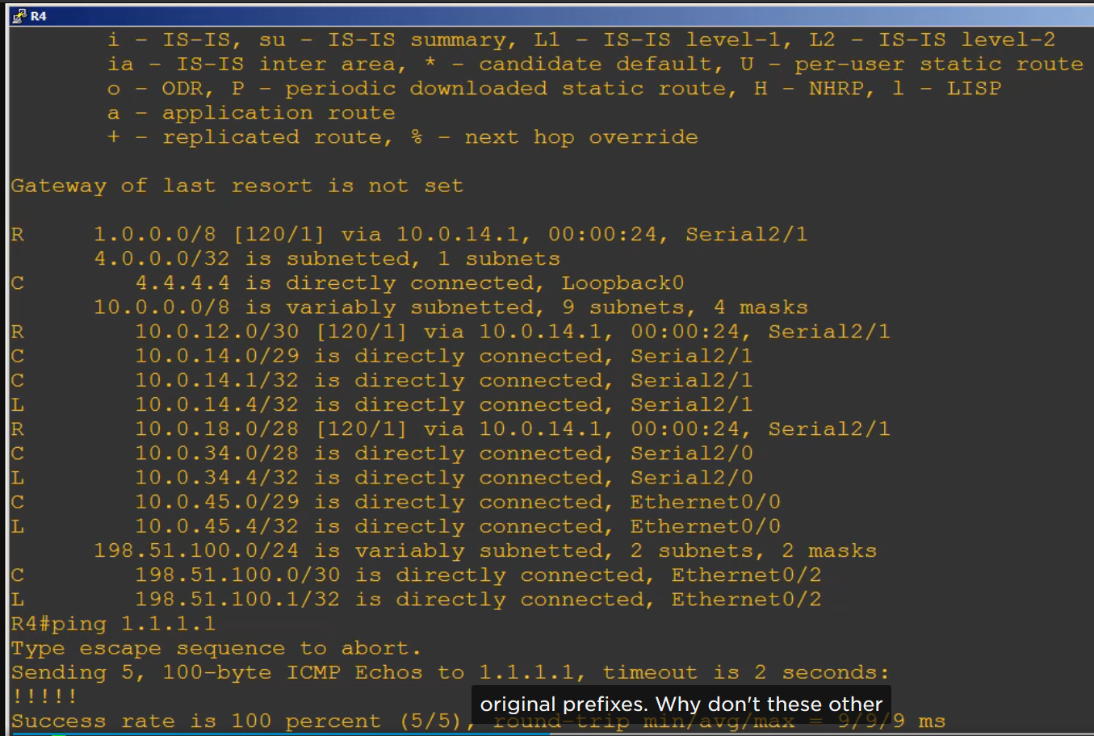

Lets go back to r4 and notice other 10.0 subnets are showing up with their orginal prefixes. Why don’t these other one get summarised.? Well, these other networks are being learned from R1, and

The link between R1 and R4 is in the same major network as all these subnets, the 10.0.0.0 class A network. It doen’s make sense for R1 to send a summary for 10.0.0.0/8 to R4 when R4 already has connected interfaces in that same major network.



Lets go ahead and advertising R4 loopback interface network 4..4.4.4

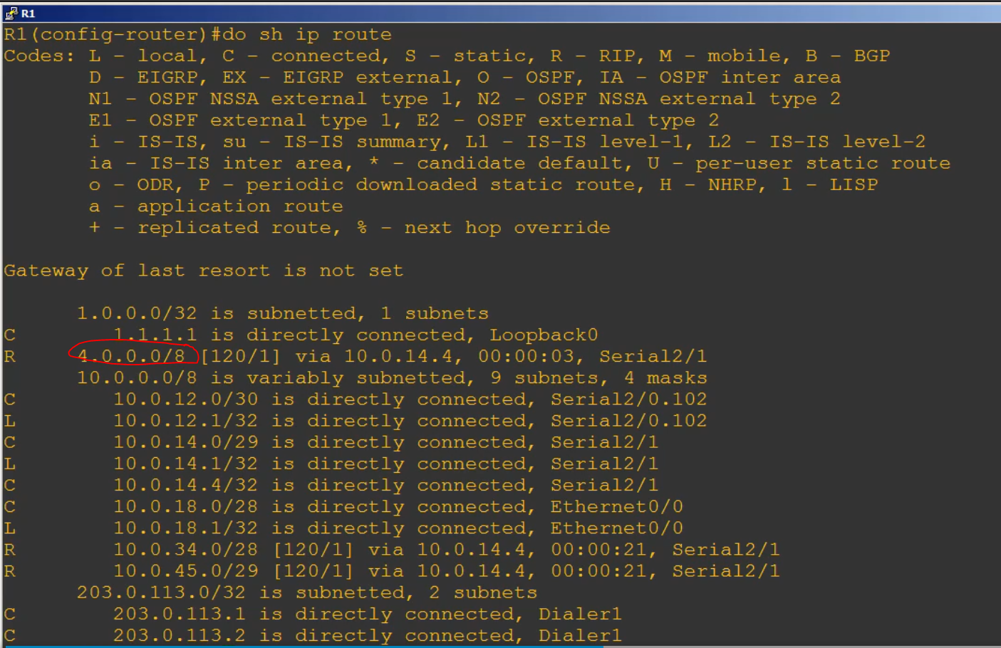

4.0.0.0/8 prefix is been run, because r4 is summarising it

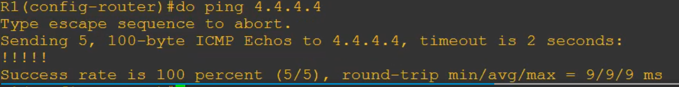

We can ping r4 loopback0 interfarce as well

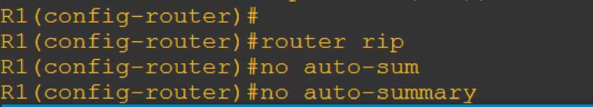

Stop it from summarising the prefix

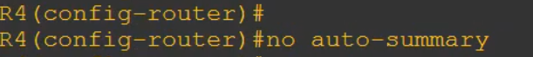

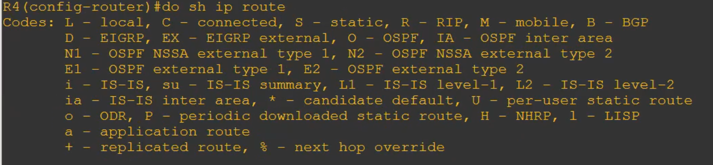

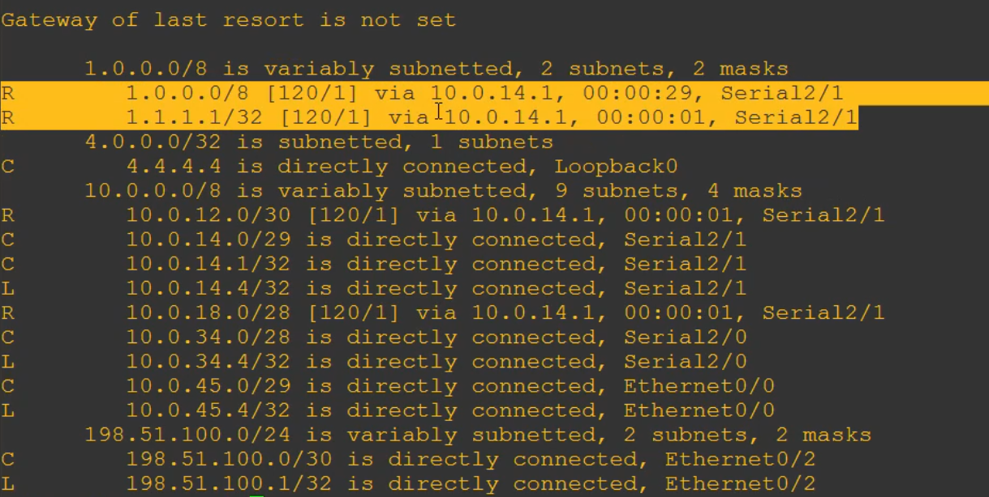

Now we got 2 routes, with one correct prefix 1.1.1.1/32



Clear the routing table and the forwarding information

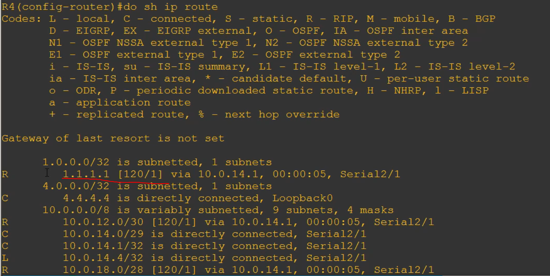

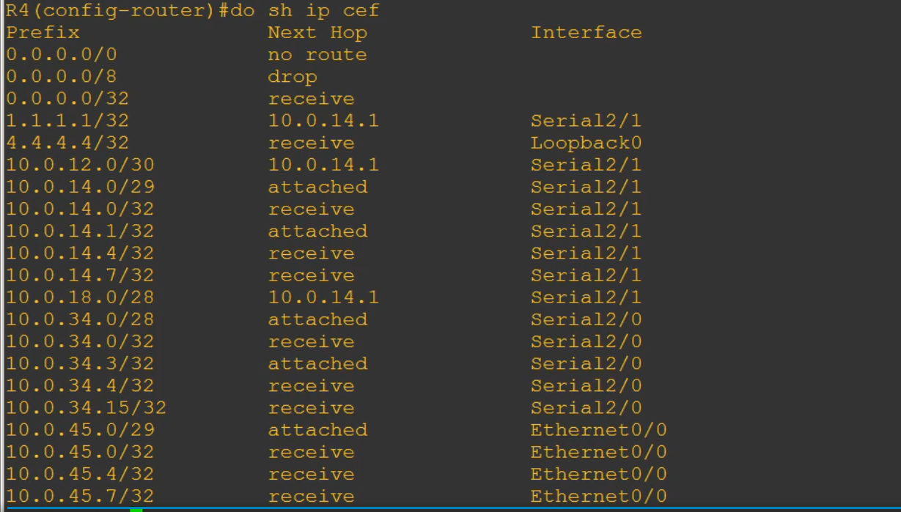

Shown all network prefix and the destine for the next hop

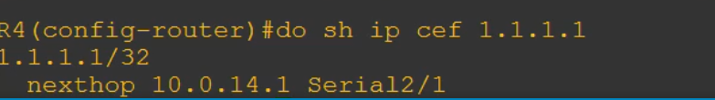

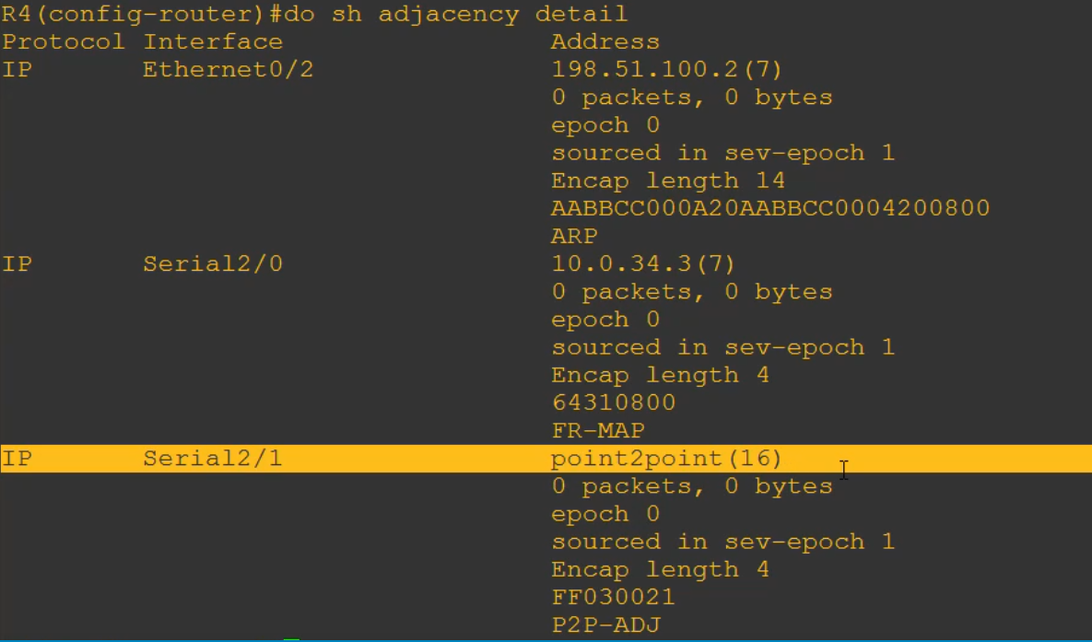

Cisco express forwarding table (ignore for now)

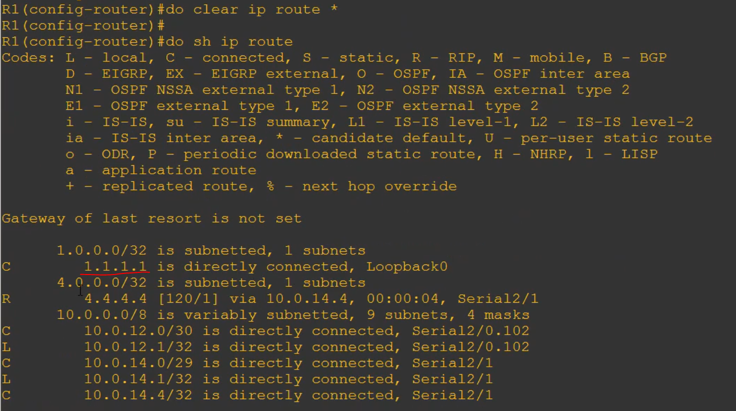

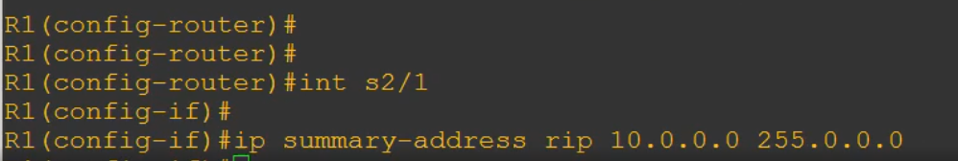

Manually summarise

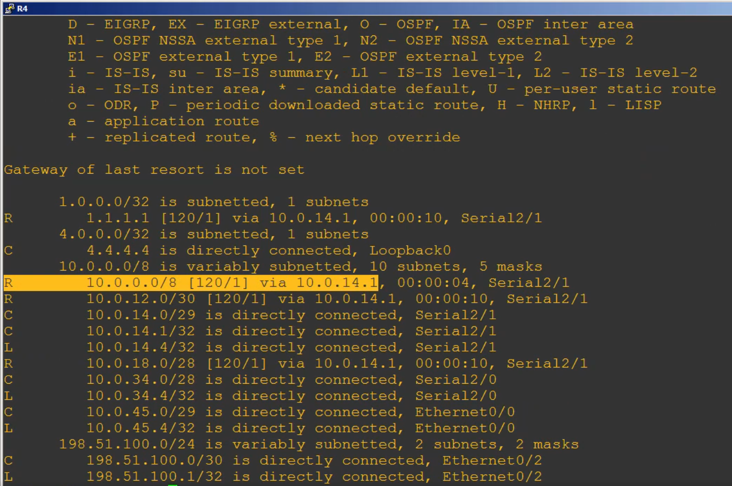



Remove or undo

